Machine Learning

**Ex:10 Decision Tree**

**Name:** Athithraja. R

**Reg.no:** 2022503702

**Aim:**

Create a Decision tree using ID3 algorithm using sklearn, and print the decision tree and confusion matrix for PIMA indian diabeties dataset

**Code:**

from sklearn.model_selection import train_test_split

from sklearn.tree import DecisionTreeClassifier, plot_tree

import matplotlib.pyplot as plt

from sklearn.metrics import confusion_matrix, classification_report

import numpy as np

import pandas as pd

data=pd.read_excel('diabetes_0.xlsx')

#print(data)

x=data.drop('Outcome',axis=1)

y=data['Outcome']

#print(x)

#print(y)

x_train, x_test, y_train, y_test=train_test_split(x,y,test_size=0.2,random_state=42)

model=DecisionTreeClassifier(criterion='entropy',random_state=42,max_depth=3)

model.fit(x_train,y_train)

y_pred=model.predict(x_test)

plt.figure(figsize=(15,10))

plot_tree(model, filled=True,

feature_names=x.columns.tolist(),

class_names=['0','1'],rounded=True,

fontsize=10,impurity=False,

proportion=False,

)

plt.title("Decision Tree for PIMA Indian Diabetes Dataset")

plt.show()

cm=confusion_matrix(y_test,y_pred)

print("Confusion Matrix: \n"+str(cm))

print("\nClassification Report:\n"+str(classification_report(y_test,y_pred)))

def entropy(y):

class_counts=np.bincount(y)

probabilities=class_counts/len(y)

return -np.sum(probabilities*np.log2(probabilities+1e-9))

def information_gain(x,y,feature):

total_entropy=entropy(y)

unique_values=np.unique(x[feature])

weighted_entropy=0

for value in unique_values:

subset=y[x[feature]==value]

weighted_entropy+=len(subset)/len(y)*entropy(subset)

return total_entropy-weighted_entropy

info_gains={feature:information_gain(x,y,feature)for feature in x.columns}

print("Information Gain: \n")

for feature,gain in info_gains.items():

print(str(feature)+" : "+str(gain))

**Output:**



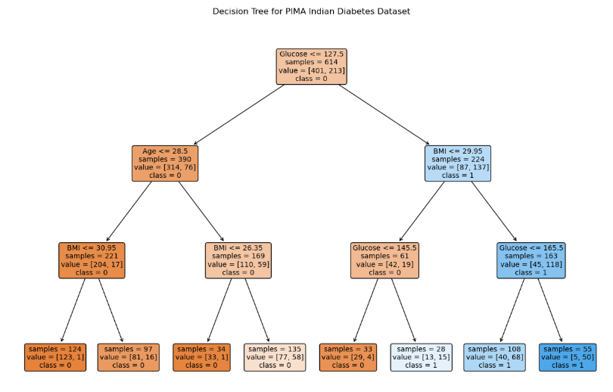

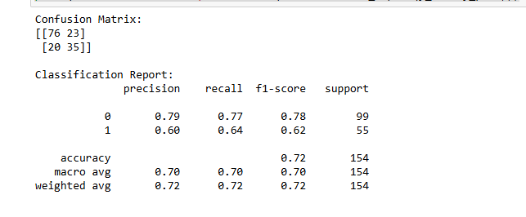

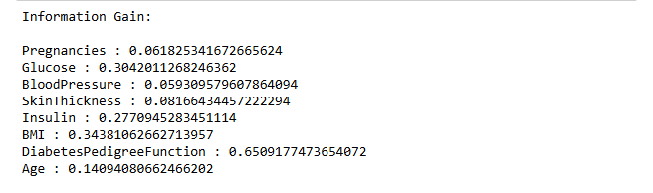

2) Play Tennis or Not

**Code:**

from sklearn.model_selection import train_test_split

from sklearn.tree import DecisionTreeClassifier, plot_tree

from sklearn.preprocessing import LabelEncoder

import matplotlib.pyplot as plt

from sklearn.metrics import confusion_matrix, classification_report

import numpy as np

import pandas as pd

data=pd.read_excel('tennis.xlsx')

label_encoder = LabelEncoder()

data['Outlook'] = label_encoder.fit_transform(data['Outlook'])

data['Temperature'] = label_encoder.fit_transform(data['Temperature'])

data['Humidity'] = label_encoder.fit_transform(data['Humidity'])

data['Wind'] = label_encoder.fit_transform(data['Wind'])

data['Play Tennis'] = label_encoder.fit_transform(data['Play Tennis'])

#print(data)

x=data.drop('Play Tennis',axis=1)

y=data['Play Tennis']

x_train, x_test, y_train, y_test=train_test_split(x,y,test_size=0.2,random_state=42)

model=DecisionTreeClassifier(criterion='entropy',random_state=42,max_depth=3)

model.fit(x_train,y_train)

y_pred=model.predict(x_test)

plt.figure(figsize=(15,10))

plot_tree(model, filled=True,

feature_names=x.columns.tolist(),

class_names=['0','1'],rounded=True,

fontsize=10,impurity=False,

proportion=False,

)

plt.title("Decision Tree for Play Tennis Dataset")

plt.show()

cm=confusion_matrix(y_test,y_pred)

print("Confusion Matrix: \n"+str(cm))

print("\nClassification Report:\n"+str(classification_report(y_test,y_pred)))

def entropy(y):

class_counts=np.bincount(y)

probabilities=class_counts/len(y)

return -np.sum(probabilities*np.log2(probabilities+1e-9))

def information_gain(x,y,feature):

total_entropy=entropy(y)

unique_values=np.unique(x[feature])

weighted_entropy=0

for value in unique_values:

subset=y[x[feature]==value]

weighted_entropy+=len(subset)/len(y)*entropy(subset)

return total_entropy-weighted_entropy

info_gains={feature:information_gain(x,y,feature)for feature in x.columns}

print("Information Gain: \n")

for feature,gain in info_gains.items():

print(str(feature)+" : "+str(gain))

**Output:**

